Ondřej Urbančík

ITeam

User Manual

PicScan beta

Abstract

1 Aplication menu 2

1. Drag-and-drop / File Picker 2

1. Automatic file processing (ON/OFF) 2

2. About 3

2 Application settings 3

1. Output folder 3

2. File Format: 3

1. Duplicate detection 4

2. Fix rotation with AI 4

3. Language selection 4

3 Preview menu 5

1. Transform viewports 5

3.1 Edit menu 6

3.2 File processing progress 7

3.3 Detection of duplicity 8

4 Resources 9

# Obsah obrázku text, řada/pruh, číslo, Písmo Popis byl vytvořen automatickyAplication menu

Picture 1 – Aplication menu

To run it, use .exe the Picscan file to launch the application. After starting, the initial menu will appear. The application offers two language options (Czech and English), in this manual the terms will be presented in Czech. The language selection can be changed in the settings (see 2.5 Language selection)

## Drag-and-drop / File Picker

The user is allowed to insert a processing folder using the "Drag-and-drop" function, then redirected to the appropriate window for editing individual cutouts. However, if the user wants to select a file manually, he selects the "File Selection" option. There is also a "Settings" button in the menu, where you can change, among other things, the already mentioned languages. If the message "Output folder does not exist" is displayed, the user must manually select the output folder in the settings. See Application settings

## Automatic file processing (ON/OFF)

There is a toggle button (ON/OFF) for automatic file processing – the ON mode means that after selecting a folder for processing, all files inside the folder are processed automatically without further user intervention. The user does not have to click through the files manually.

## About

The last folder in the initial menu is the About button, where information about the application is displayed (authors, versions, repository, etc.). You can also send feedback to the development team itself if an unexpected error occurs.

# Obsah obrázku text, snímek obrazovky, software, displej Popis byl vytvořen automatickyApplication settings

Picture 2 -Application settings

## Output folder

By default, the "output" output folder is set, which can be changed according to the user's preference. If the message "Output folder does not exist" is displayed in the main menu, the user selects any output folder, e.g. C:\Users\OneDrive\Desktop\New Folder.

## File Format:

In the settings, you can change the output format of individual files. The default format is jpg. Can also be changed to png.

## Duplicate detection

It is also possible to set the duplicate detection mode. If similar cutouts are found in the process of processing the folder, the program detects them and queues them. The user then decides which cutouts he wants to keep or discard. More info in Edit menu/Duplicate detection.

## Fix rotation with AI

An optional function of the program is the correction of rotation of cut-outs using artificial intelligence – it automatically completes the incorrectly scanned cut-out to the correct size.

## Language selection

The last item can be used to change the default language of the application (restart required).

# Obsah obrázku text, snímek obrazovky, Multimediální software, software Popis byl vytvořen automatickyPreview menu

Picture 3 – preview menu with pictures

After successful selection of the file for processing, the user is shown the file in the left "preview" window and individual, detected and processed cutouts by the program in the right part.

## Transform viewports

Cut-outs can be manually rotated or their size/shape adjusted in the appropriate edit mode. There is also a button to discard any viewport (X). If the user has inserted a folder with multiple files for processing, he clicks the "Next" button to load the next file, and the process repeats until no file remains in the folder. If the user does not want to browse the folder manually, he can select the "Auto" mode, which will cause automatic processing of all remaining files in the folder (the same functionality of the ON/OFF button on the main page).

## Obsah obrázku text, snímek obrazovky, software, Multimediální software Popis byl vytvořen automatickyEdit menu

Picture 4 – edit menu

When selecting the button (꙱), the user is redirected to the edit menu, where it is possible to manually change the dimensions of the detected cut-out "Select points". The viewport is defined by three points. Two points can be manipulated at will, and the third we adjust the distance from the two previous ones. You can also zoom in and out of a file using the (+)(-) buttons. If the selection of points does not suit, the original settings can be restored using the "Restore" button.

## Obsah obrázku snímek obrazovky, text, design Popis byl vytvořen automatickyFile processing progress

Picture 5 – file processing progress

All the time, the user is informed about the progress of processing the folder (remaining processing time and number of processed files). Finally, the user is shown a panel with the inscription "Completed" with the option to return to the start page or open the folder in which the individual cutouts were saved.

## Obsah obrázku snímek obrazovky, text, Multimediální software, software Popis byl vytvořen automatickyDetection of duplicity

Picture 7 – detection of duplicity

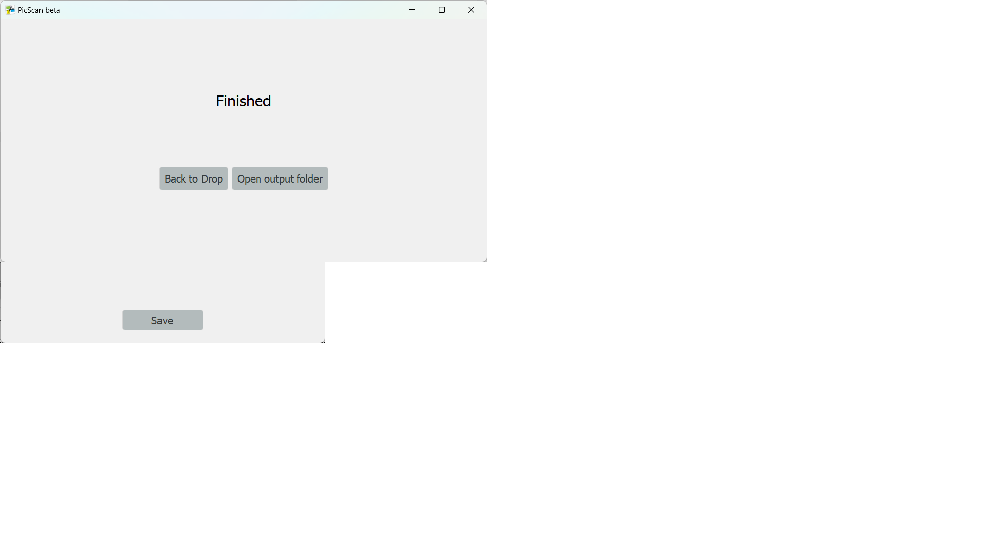PIf the user has selected the duplicate detection option, he will have to decide during processing which cut-outs to leave for storage in the folder and which to discard and delete. Figure 5 shows cut-outs that were detected with some similarity (right part) to the currently shown viewport (left part). Similarity is expressed in percentage points. The user is offered several options. If he wants to save the currently selected crop (left part), he selects the option "Keep" / "Keep All", otherwise he chooses "Delete" and the cutout is discarded or the button (X). If the user likes a detected cutout with a certain similarity (right part), he can use the button (←) to select a cutout that moves to the left part and the detection process is repeated for that viewport.

Picture 8 – process finished

# Resources

Repository: <https://github.com/krystofffff/PicScan>

Authors: Matin Dušek, Ondřej Urbančík, Kryštof Krmaschek, Lucie Solková